Compilation instructions for Windows 10 OS

(Windows 10, Microsoft Visual Studios 2017)

1. Download sfml using the link below
   1. <https://www.sfml-dev.org/download/sfml/2.5.1/>
2. Download Zip folder of game below
   1. <https://github.com/BrianLiu1319/cs29groupProject>
   2. 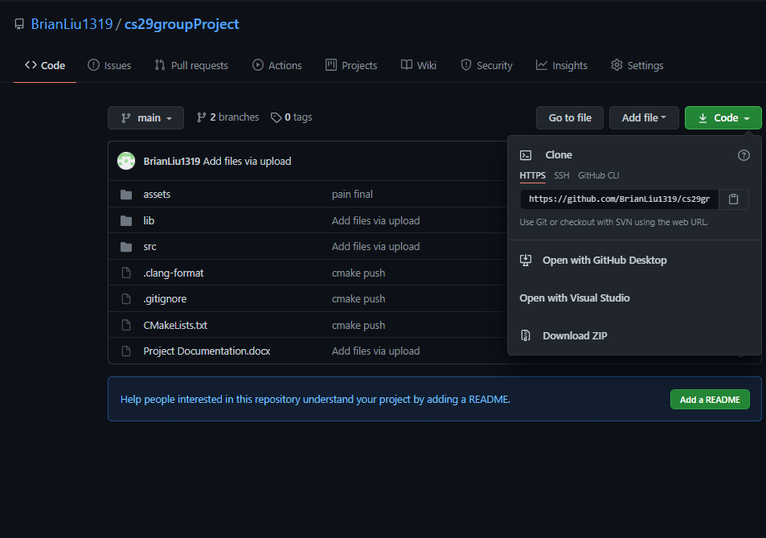
3. Create an Empty Project
   1. 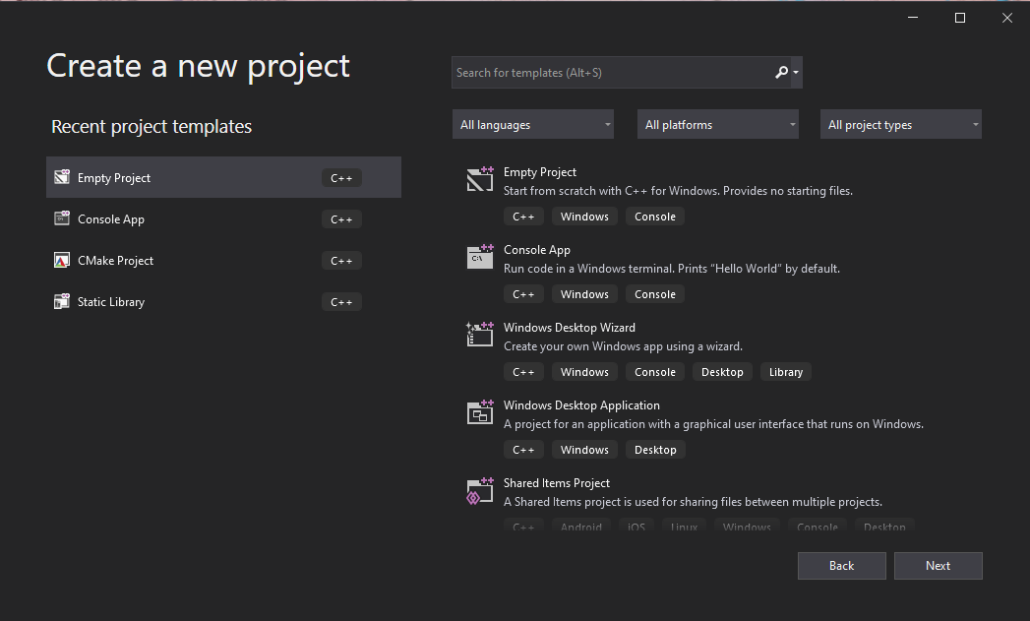
4. Extract assets, libs, src to project directory
   1. 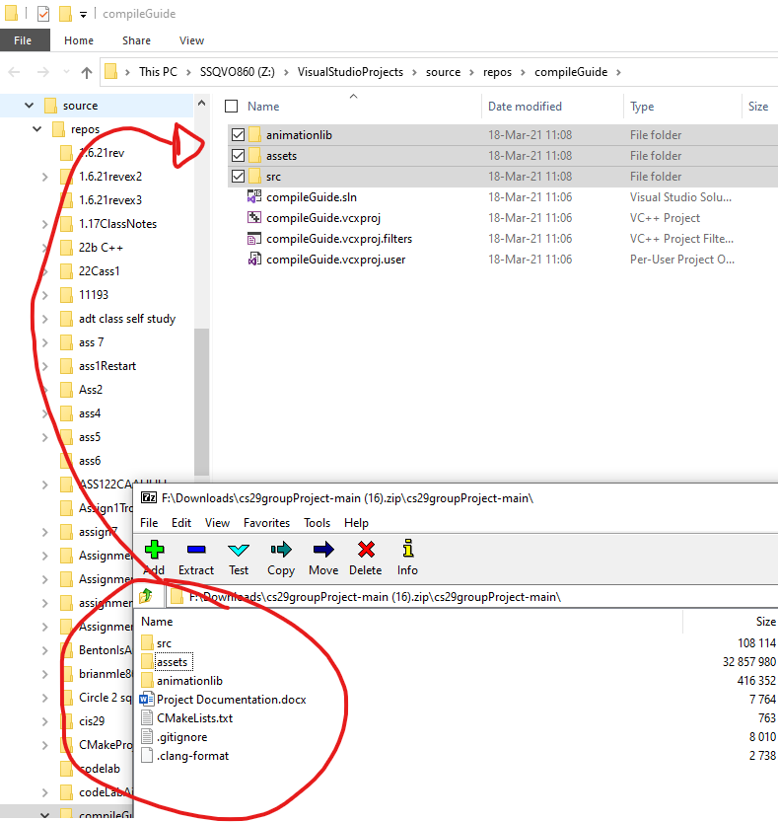
5. Add existing files into project from src folder
   1. 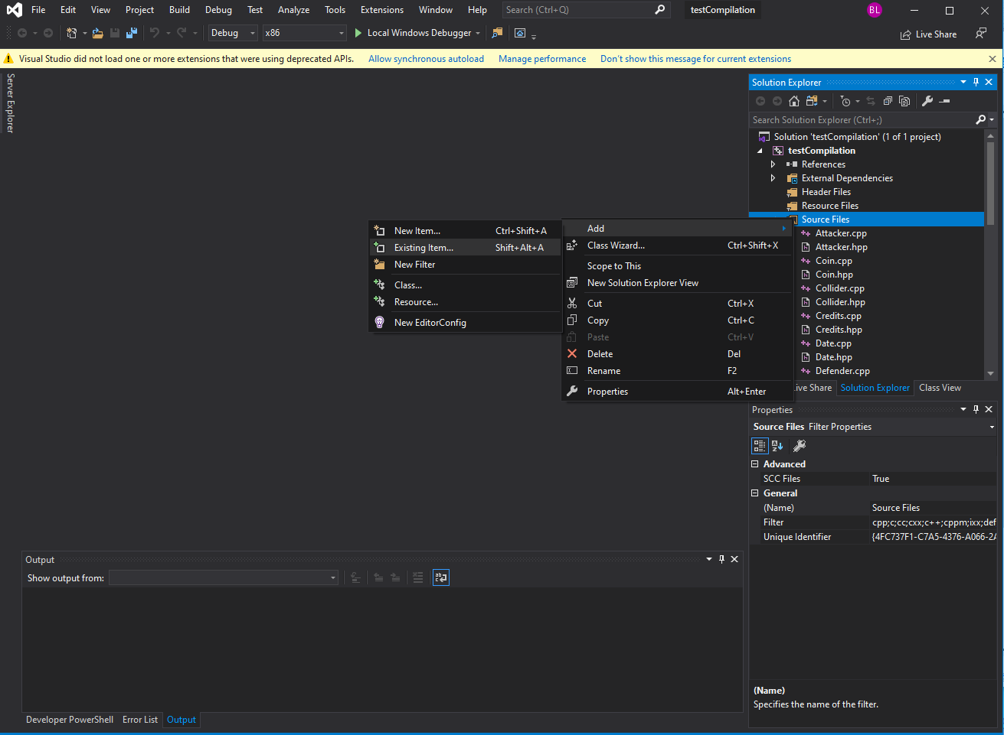
   2. 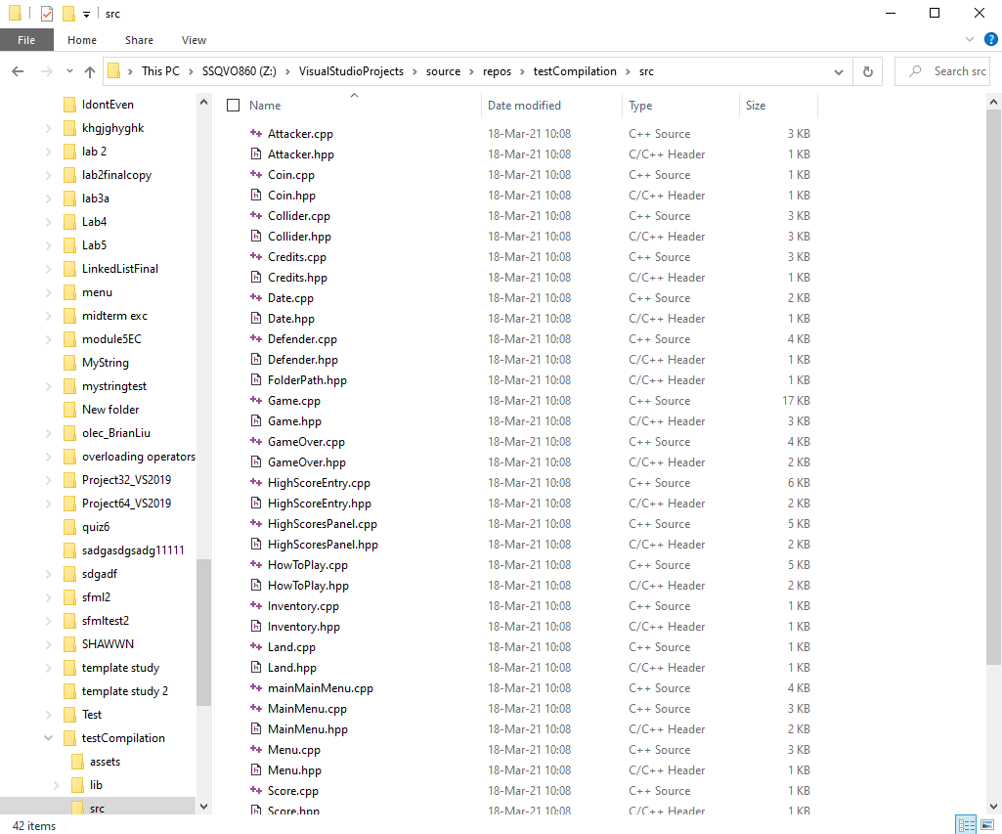
   3. 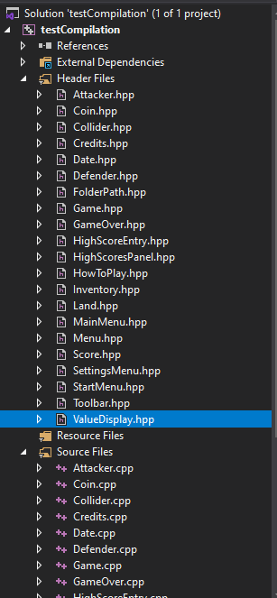
6. Go to FolderPath.hpp and change to your asset folder library
   1. **Be sure it has forward slashes and the “/assets/” at the end**
   2. 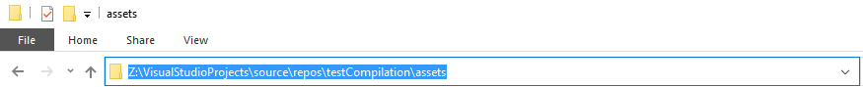
   3. 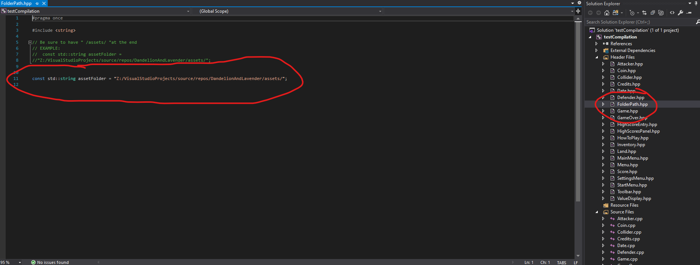
7. Right click project and select its properties to finally link sfml and animation library
   1. 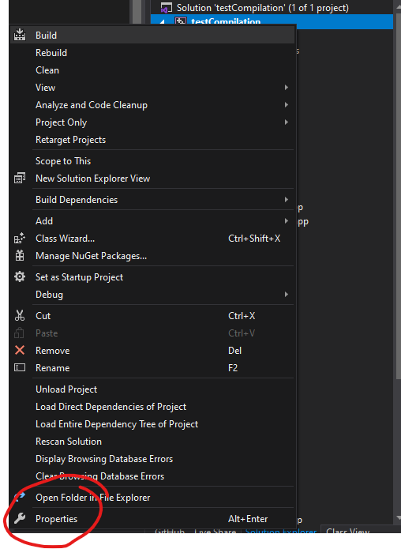
8. Go to “C/C++” > “Additional Include Directories”
   1. Link SFML include folder (found in SFML folder)
   2. Link include folder in animationlib (found in projectFileExplorer > lib > include )
   3. Be sure they are in the correct order
   4. 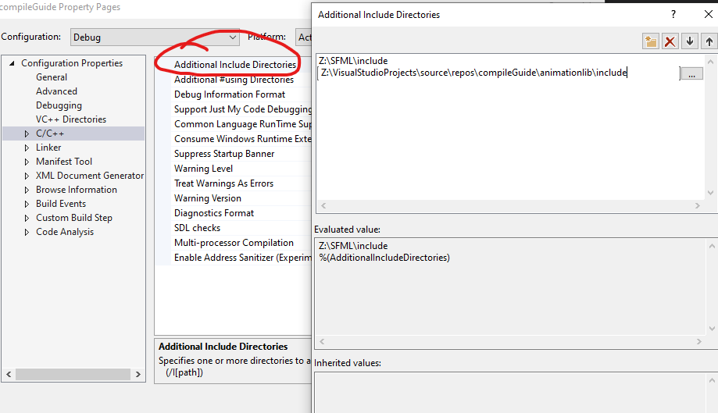
9. Go to “Linker” > “General” > “Additional Library Dependencies”
   1. Link SFML libs (found in SFML download)
   2. Link animationlib (found in fileExplorer)
   3. 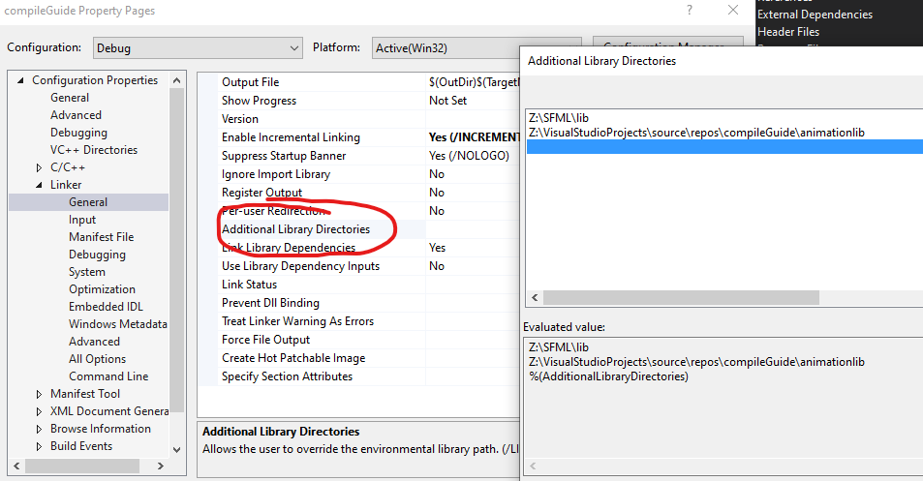
10. Go to “Linker” > “Input” > “Additional Dependencies”
    1. Link the following dependencies :
       1. sfml-audio-d.lib
       2. sfml-graphics-d.lib
       3. sfml-window-d.lib
       4. sfml-system-d.lib
       5. Animation.lib
    2. 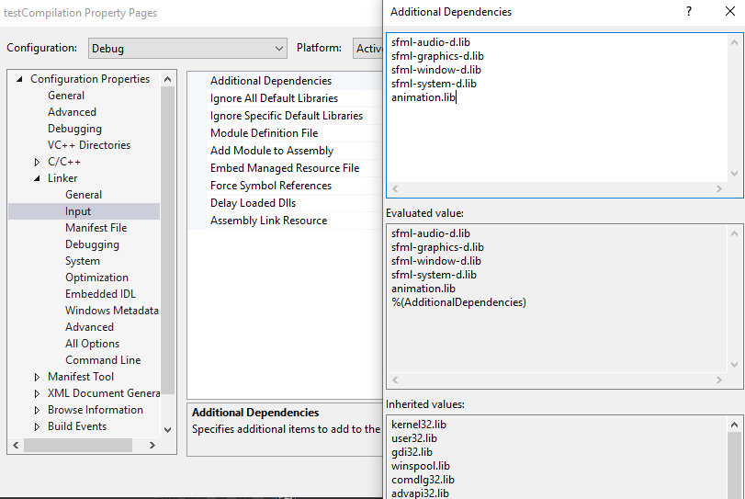
11. Press apply and exit out of properties
12. Move SFML dll’s to solution folder
    1. (found in SFML/bin)
    2. 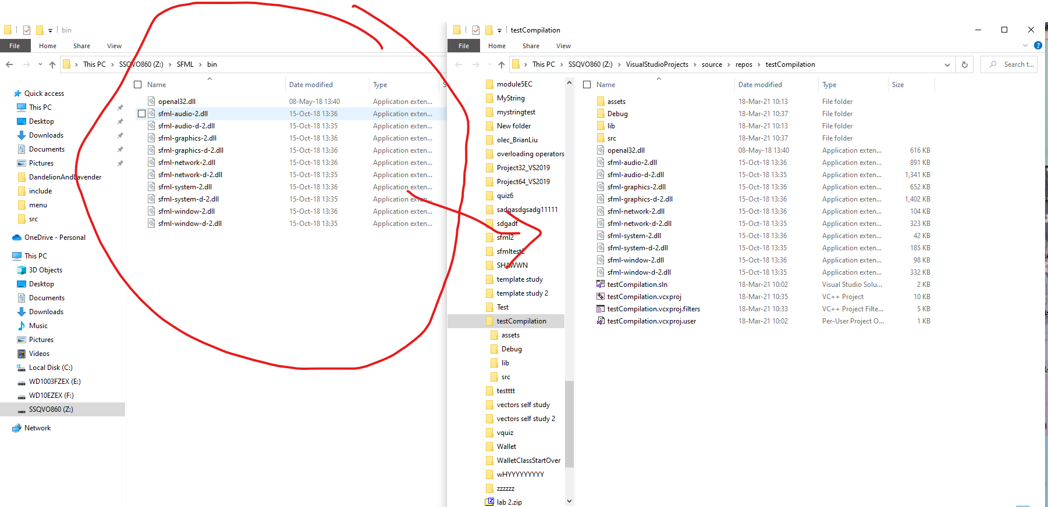
13. Build Solution and pray that it runs